**Ardens Structured Medication Review Template**

**EMISweb**

The Ardens Structured Medication Review template has been designed to support practices with a comprehensive medication review for the patient, aligning with the [PCN DES 2020/21](https://www.england.nhs.uk/publication/des-contract-specification-2020-21-pcn-entitlements-and-requirements/) requirements.

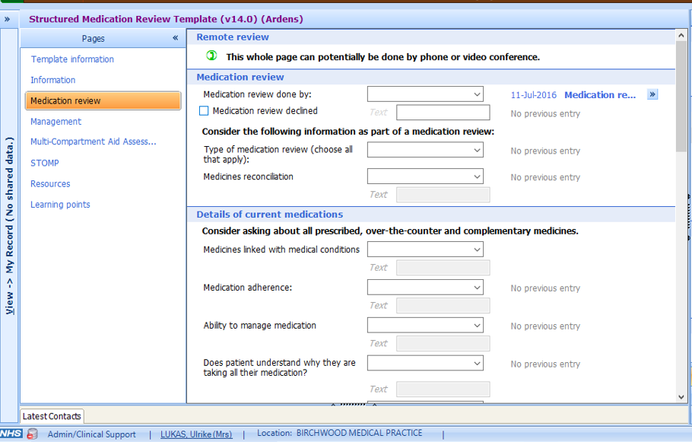

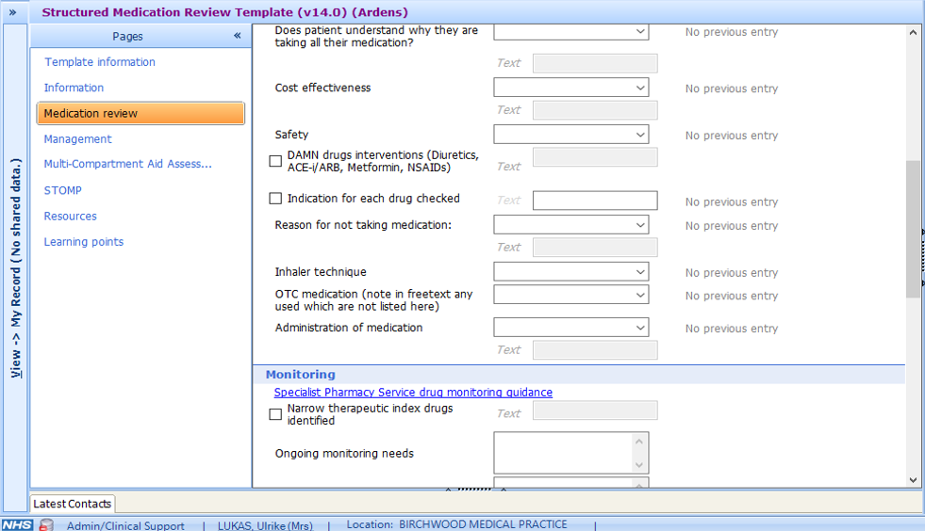

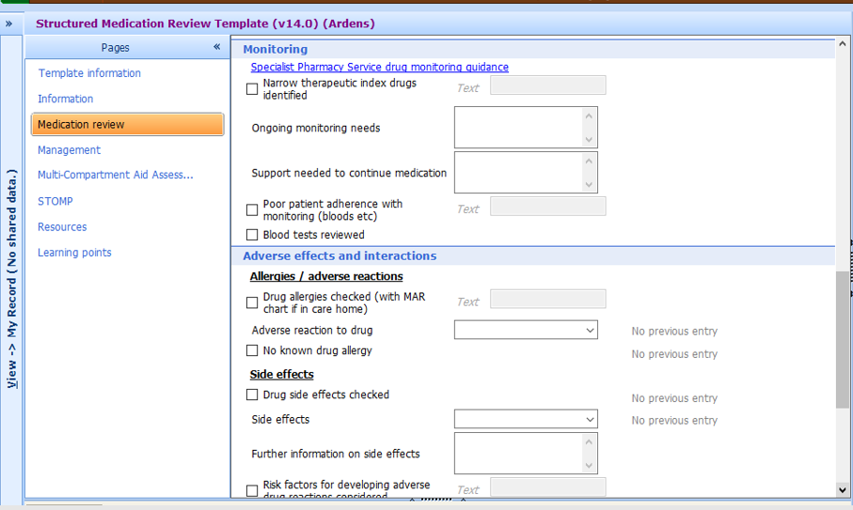

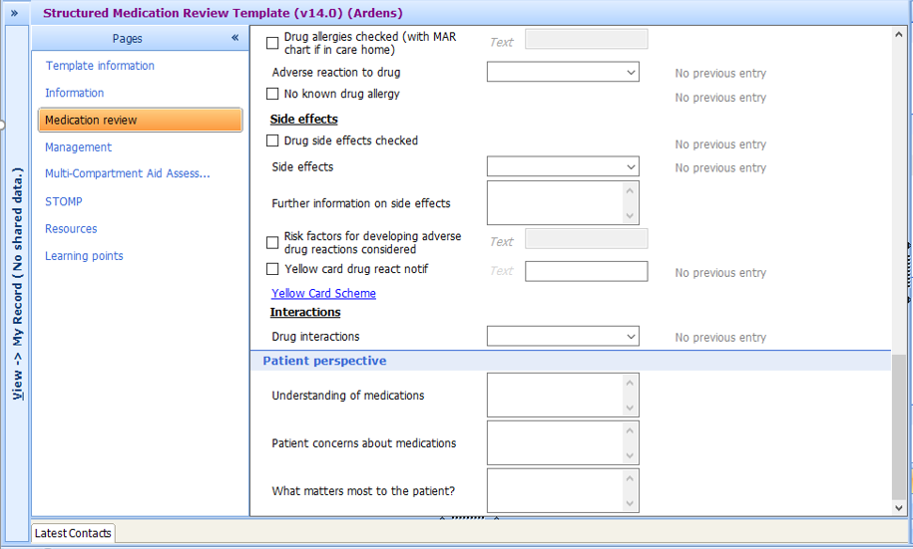

The Structured Medication Review template can be accessed in one of the following ways:

* Select patient
* Click on the **Run Template** option within the consultation.
* Click on the **Add**> **Data using Template** option outside of a consultation.

Clicking on either of the options above will display the Template Picker screen. Search for the '**Structured Medication Review Template**' using the search box provided or folder navigation pane. Select the template and click **OK**.

*Can not see any of the above template?*  Check the template has been activated in your EMIS system.

**If any further assistance is required on the process above, please contact Ardens support on:**[**support-emis@ardens.org.uk**](mailto:support-emis@ardens.org.uk)

**SystmOne**

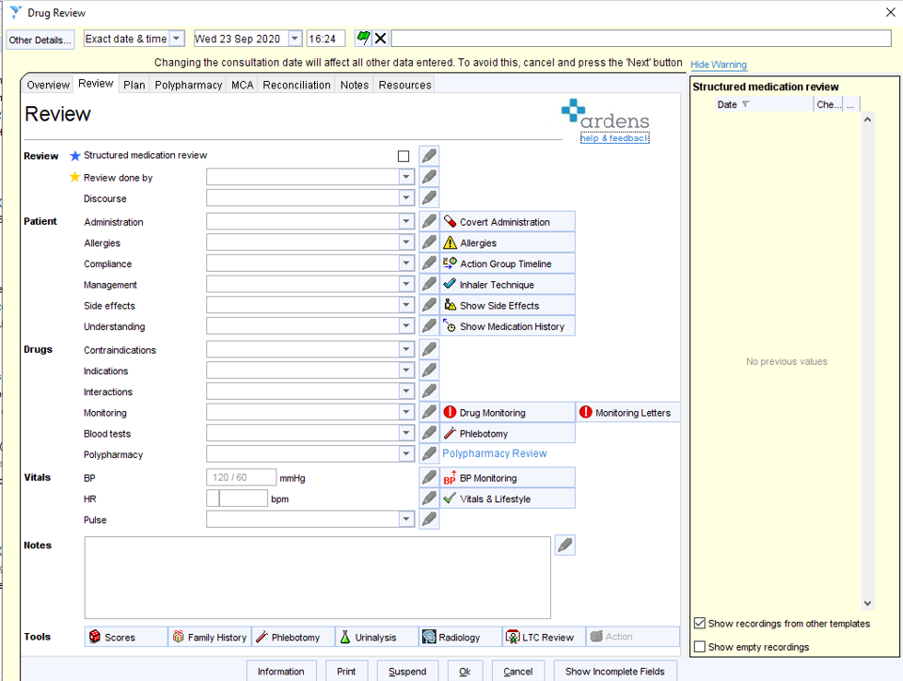

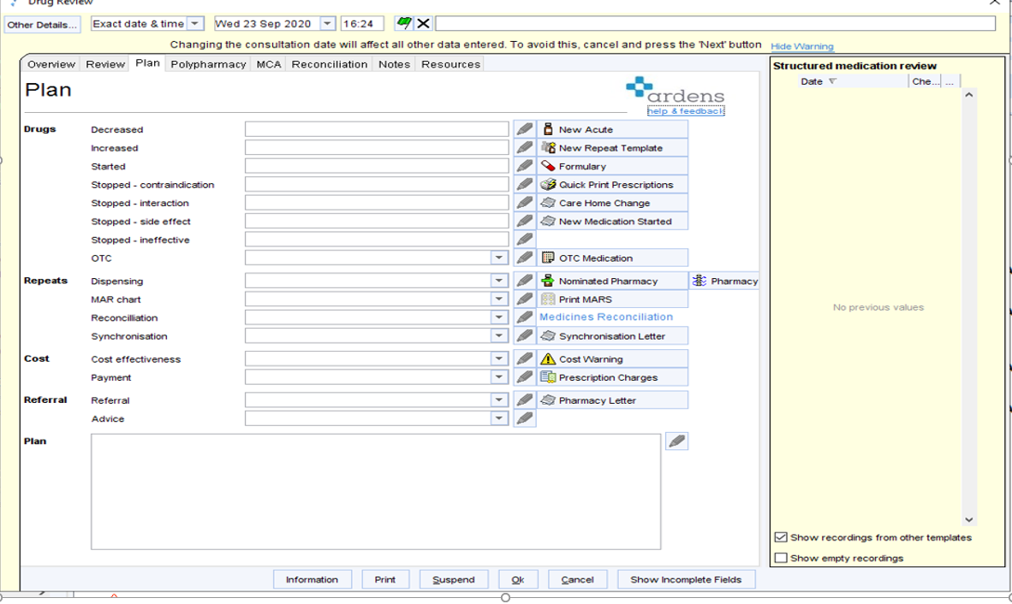

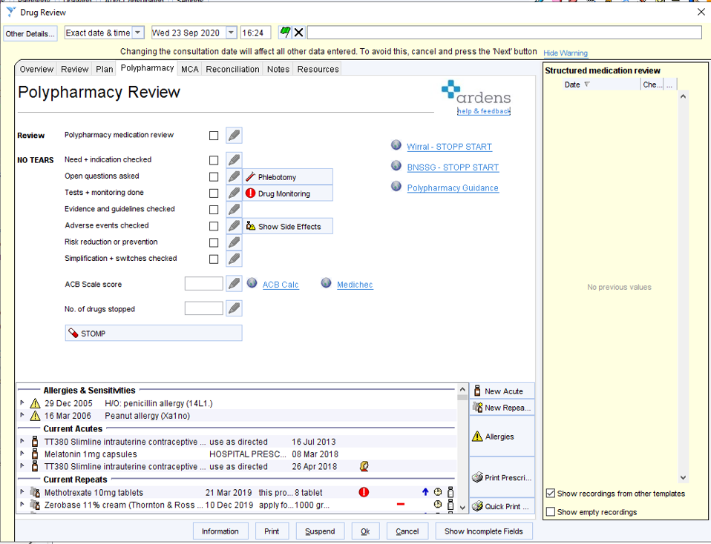

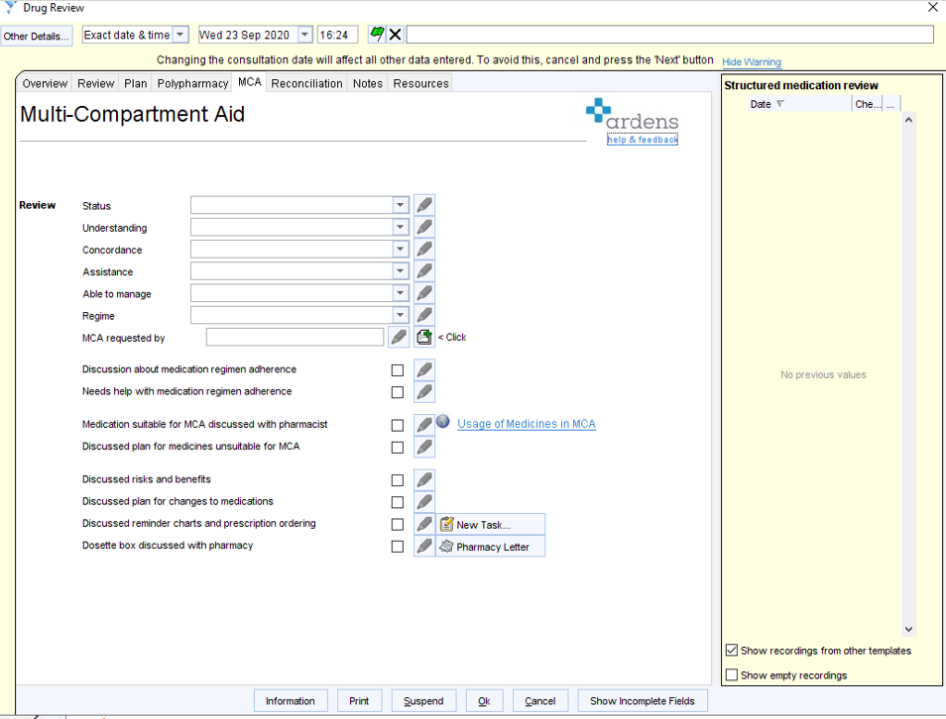

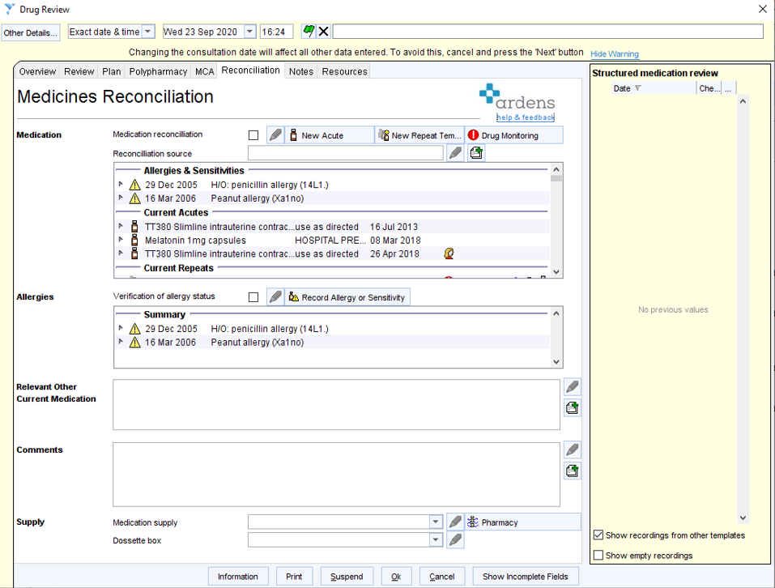

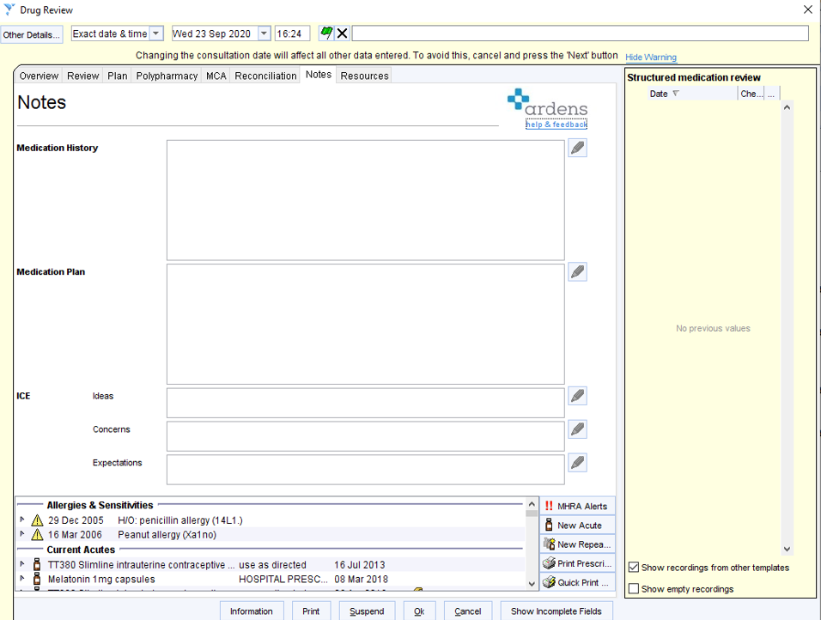

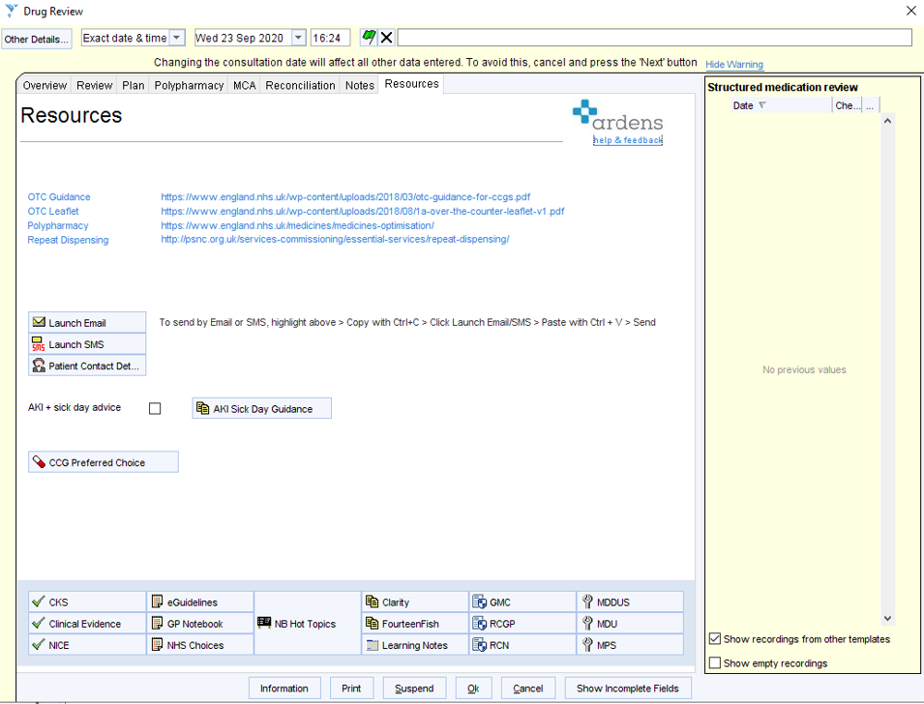

To access this template on **SystmOne th**ere are several options:

1. The search in the bottom left hand corner of your screen – type ‘drug’ in here and it should come up.

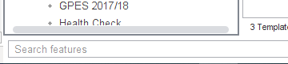

1. From the pharmacist OR pharmacy technician template there is a button for drug review as shown below.

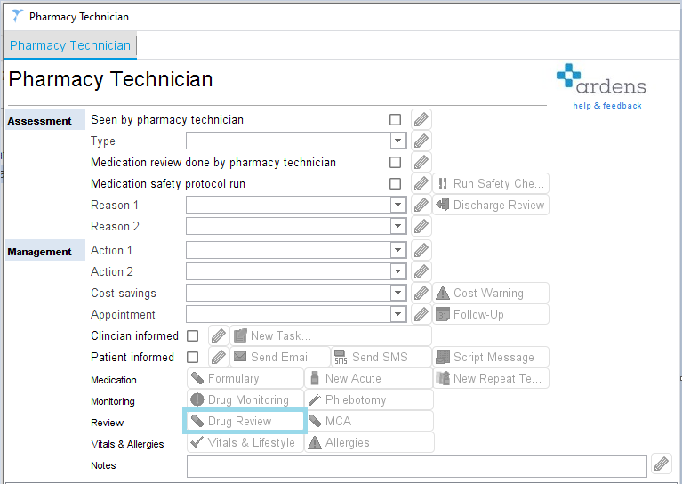

1. From the Auto-consultation tab

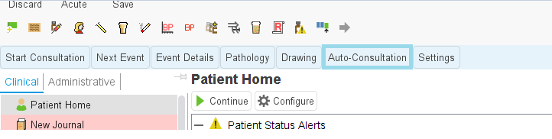

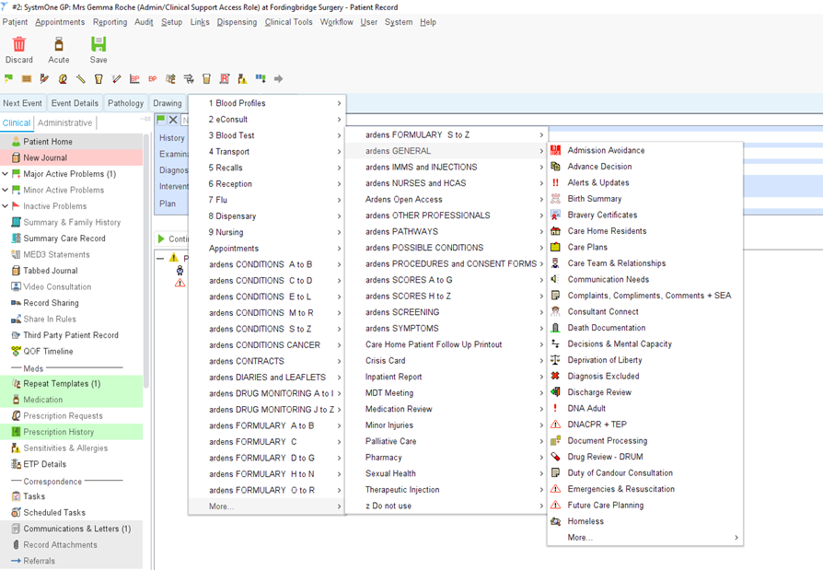

For further support contact the ardens support team [support@ardens.org.uk](mailto:support@ardens.org.uk)